**Animal Shelter Management**

**Software Requirements Specification**

**CEN 3031, Fall, 2019**

**Modification history:**

|  |  |  |  |
| --- | --- | --- | --- |
| Version | Date | Who | Comment |
| V0.1 | 9/20/2019 | Seth | Setup SRC on github |
| V0.2 | 9/30/2019 | Seth | Create patients scene and methods |
| V0.3 | 10/15/2019 | Team | Kennel scenes and methods |
| V0.4 | 10/19/2019 | Josh  Peter | Update class relationships  Create initial README |
| V0.5 | 10/27/2019 | Josh | Create employee system |
| V0.6 | 11/09/2019 | Kevin  Josh | Create task system |
| V0.7 | 11/11/2019 | Seth | Added patients view functionality |
| V0.8 | 11/27/2019 | Kevin | Created adoptable flags |
| V0.9 | 12/02/2019 | Seth | Added style changes to the project |
| V0.10 | 12/03/2019 | Peter | Updated README |

**Team Name:** Tuesday Team 1

**Team Members:**

· Peter Look – pjlookii2220@eagle.fgcu.edu

· Seth Graham – stgraham1506@eagle.fgcu.edu

· Joshua Colicchio – jacolicchio8554@eagle.fgcu.edu

· Joseph Racz – jjracz0621@eagle.fgcu.edu

· Kevin Zink – kmzink1079@eagle.fgcu.edu

**Contents of this Document**

Introduction

· Software to be Produced

· Definition, Acronyms, and Abbreviations

Product Overview

· Assumptions

· Use Case Diagram

· Use Case Descriptions

Specific Requirements

**SECTION 1: Introduction**

Software to be Produced:

The application will allow for workers to check-in new animals as well as adopt them out, edit the animal information, scheduled events such as cleanings or vet check-ups, and search for animals by collar ID or species. It should also track the time the animals have been in the shelter. Animals information should include the main species & sub-species.

Definitions, Acronyms, and Abbreviations:

* **Adoption** is the act of taking something on as your own. In this scenario, we mean as a pet.
* **Tasks** Day to day jobs to maintain the building, kennels, and animals, and ensure the business runs smoothly.

**SECTION 2: Product Overview**

Assumptions:

* We are assuming the software will be used at Animal Shelters exclusively.

Use Case Diagram:

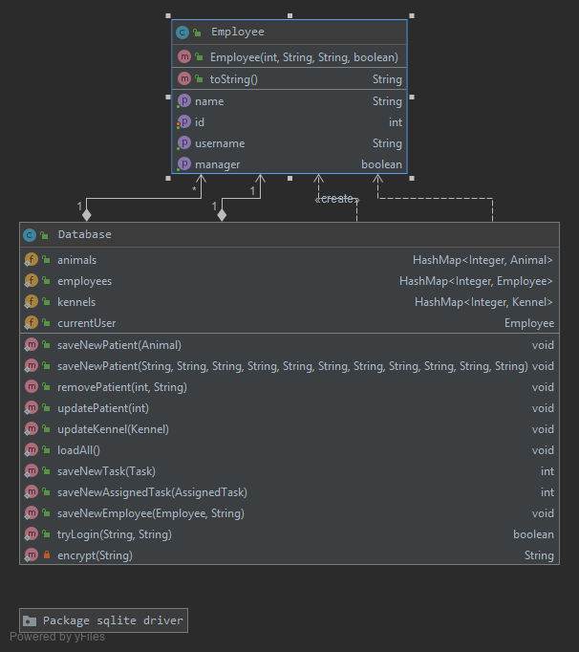

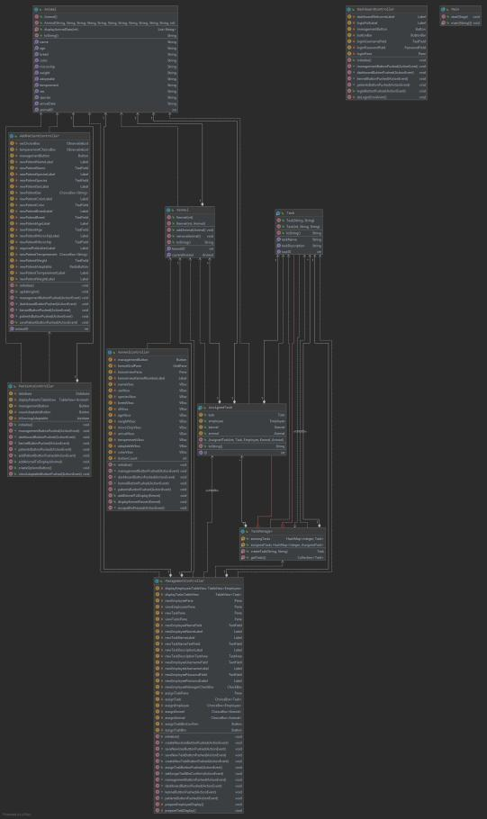

Use Case Descriptions:

* Check in/ Adopt out – Employees will check in and adopt out an animal.
* Assign Kennel – Employees will assign an animal to an open kennel.
* Set/Remove tasks – Manager will set animal tasks and employees will be assigned to them.
* Handle tasks – Employees will handle and complete tasks.
* View/Edit schedule – Manager will view and edit schedules.
* Create adoption form – Employee will create and complete an adoption form.
* Track time in facility – Software will automatically track and tally time in the facility.

**SECTION 3: Specific Requirements**

|  |
| --- |
| **No:** 1-16 |
| **Statement:**  1) The system shall keep track of all animals currently at the shelter. COMPLETE  2) The system shall have an interface for employees to add and remove animals. COMPLETE  3) The system shall allow employees to edit animal information based on the type of animal and species. COMPLETE  4) The system shall give employees the ability to schedule medical appointments for each animal. PENDING  5) The system shall have an ID system for each animal to keep track of new patients and previous patients. PENDING  6) The system shall allow employees to search for animals using their unique identification. COMPLETE  7) The system shall track the length of time each animal has been in the facility. COMPLETE  8) The system shall allow employees to place animals in kennels. COMPLETE  9) The system shall track which kennels are currently occupied by an animal. COMPLETE  10) The system shall display all known attributes of an animal when viewing the kennel. COMPLETE  11) The software shall track employees. COMPLETE  12) The software shall assign employees tasks. COMPLETE  13) The software shall track all employee tasks. PENDING  14) The software shall display which animals are able to be adopted or not. COMPLETE  15) The software shall keep track of employee hours. PENDING  16) The software shall Create new employee’s. COMPLETE |